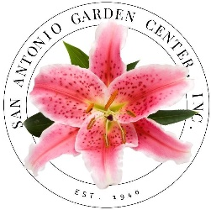
GARDENERS AT LARGE new member!

Name

Address
City Zip

Best Phone

Email

Dues $20 □ Paid

I would like to:
□ Attend monthly meetings
□ Attend Floral Design School Classes
□ Volunteer for Operation Christmas Cheer
□ Work at the Annual Plant Sale
□ Work at the Annual Flower Show

If you don’t want to commit now, just check off what you are interested in and we’ll contact you later with more information.
Date

Gardeners at Large membership includes Federation Dues to the National Garden Clubs, Inc.; and receipt of the San Antonio Garden Center Newsletter and Yearbook. Cost is $20.00 a year, due every May.
Please remit form and monies to:

San Antonio Garden Center
c/o Gardeners at Large
3310 N. New Braunfels
San Antonio, Tx 78209.

Meetings are held the 1st Wednesday of the month, September through May. The Plant Sales and Morning Coffee at start at 9:30 am; 10 am the program and business meeting.

It shall be the mission of the San Antonio Garden Center to inform and educate both our members and the public about gardening, floral design, horticulture and landscaping, to provide garden therapy for individuals and groups for whom the activity might be beneficial, to create public interest in and to work for conservation of plants and beauty spaces, and to coordinate the efforts of our member clubs and individual members in achieving these purposes…

