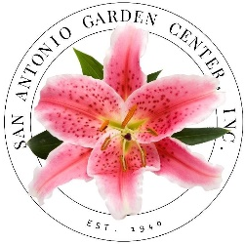
GARDENERS AT LARGE
Membership / Renewal Form
info@sanantoniogardencenter.org
SanAntonioGardenCenter.org ▪ (210) 824-9981

Name Date

Address
City Zip

Best Phone

Email

Dues $20 □ Paid □ Check #

I would like to:

□ Attend monthly meetings

□ Attend Floral Design School Classes

□ Volunteer for Operation Christmas Cheer

□ Volunteer to work at the Annual Plant Sale

□ Be a Docent at the Annual Flower Show

If you don’t want to commit now, just check off what you are interested in and we’ll contact you later with more information.

If you are renewing your Gardeners at Large membership, please send your membership dues
along with this form to:

San Antonio Garden Center
1330 N. New Braunfels
San Antonio, TX 78209

Contact:

Bea Moreno
3rd Vice President, Gardeners at Large
(210) 737-6442
beatrice_moreno@outlook.com

